**Product Datasheet**

**3-port Gigabit PoE Extender**

**(ONV-PSE-PD3302S)**

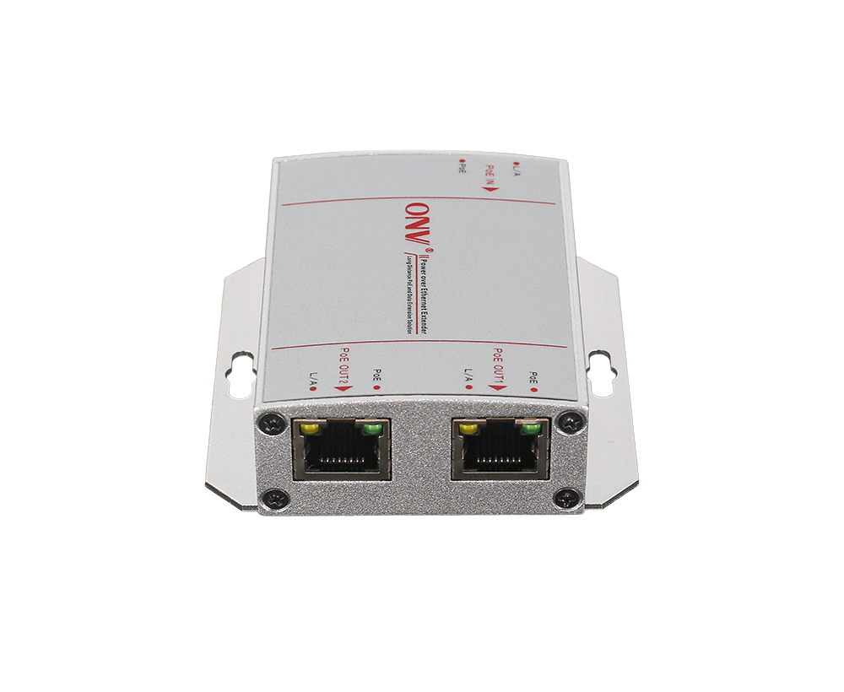

**OVERVIEW**

The ONV-PSE-PD3302S is a Gigabit PoE Extender. It has 2*10/100/1000M RJ45 ports and 1*10/100/1000M RJ45 port. Port 1-2 can support IEEE802.3af/at PoE standards. The uplink port is a power-receiving port that complies with the IEEE802.3af/at standard. Compatible with both 1236 and 4578 power supply methods. As a PoE power supply device, it can automatically detect and identify power-receiving devices that meet the standard and power them through the network cable. Wireless AP, IP camera, IP phone, video access control intercom, and other PoE terminal devices can be powered through the network cable. It meets the network environment that requires a high-density PoE power supply and lossless bandwidth to solve the twisted pair PoE transmission application within a range of 200 meters. It is suitable for hotels, campuses, parks, scenic spots, factory dormitories, and small and medium-sized enterprises to build economical and efficient networks. Unmanaged mode, plug and play, no configuration, simple and convenient to use.

**FEATURE**

* **Gigabit access**
* Support non-blocking wire-speed forwarding.
* Support full-duplex based on IEEE 802.3x and half-duplex based on Backpressure.
* Provides 3*10/100/1000Base-T RJ45 ports. The uplink power port is the power receiving port, flexible networking to meet the power supply and transmission needs of scenarios within 200 meters.
* **Smart PoE power supply**
* 2*10/100/1000Base-T RJ45 ports support PoE, meeting the PoE power supply requirements of various scenarios in the security field.
* Comply with IEEE802.3af /at PoE standards to automatically identify PoE devices for power supply without damaging non-PoE devices. The max power output using 1*PoE is 25W, and the sum of the max power when using 2*PoE output does not exceed 25W.
* **Stable and reliable**
* CCC, CE, FCC, RoHS.
* Plug and play, no configuration, easy to use and maintain.
* The user-friendly panel can show the device status through the LED indicators of PWR, Link, and PoE.
* Low power consumption, aluminum alloy housing, and excellent heat dissipation to ensure the stable operation of the PoE extender.
* When the repeater is working, no external power supply, and it can easily solve the problem of sufficient bandwidth and power network cable transmission within 200 meters.

**TECHNICAL SPECIFICATION**

|  |  |
| --- | --- |
| **Model** | **ONV-PSE-PD3302S** |
| **Interface Characteristic** | |
| Fixed Port | 2*10/100/1000Base-T PoE ports (Data/ Power)  1*10/100/1000Base-T uplink power receiving port (Data/ Power) |
| Ethernet Port | Port 1-3 can support 10/100/1000Base-T(X) auto-sensing, full/ half duplex MDI/ MDI-X self-adaption |
| Twisted Pair Transmission | 10BASE-T: Cat3,4,5 UTP (≤100 meters)  100BASE-TX: Cat5 or later UTP (≤100 meters)  1000BASE-T: Cat5e or later UTP (≤100 meters) |
| **Chip Parameter** | |
| Network Protocol | IEEE802.3 10BASE-T, IEEE802.3i 10Base-T,IEEE802.3u 100Base-TX, IEEE802.3ab 1000Base-T, IEEE802.3x |
| Forwarding Mode | Store and forward (Full wire speed) |
| Switching Capacity | 6Gbps (non-blocking) |
| Forwarding Rate@64byte | 4.46Mpps |
| MAC | 2K |
| Buffer Memory | 2M |
| Jumbo Frame | 1536byte |
| LED Indicator | Power: PWR (Green), Network: Link (Yellow), PoE: PoE (Green) |
| **PoE& Power Supply** | |
| PoE Port | 2 port |
| Power Pin Assignment | 1/2(+), 3/6(-), Optional 4/5(+), 7/8(-) |
| Single-port Max PoE power | 30W, IEEE802.3af/at |
| Total PWR/ Input Voltage | 30W/ (AC100-240V) |
| Power Consumption | Standby<4W, full load<30W |
| **Physical Parameter** | |
| Operation Temp/ Humidity | -20~+55°C, 5%~90% RH non condensing |
| Storage Temp/ Humidity | -40~+80°C, 5%~95% RH non condensing |
| Dimension (L*W*H) | 80*76.5*27mm |
| Net /Gross Weight | 0.2kg/ 0.3kg |
| Installation | Desktop, Wall mount |
| **Certification& Warranty** | |
| Lightning Protection | Lightning protection: 4KV 8/20us; Protection level: IP30 |
| Certification | CCC, CE mark, commercial, CE/LVD EN62368-1, FCC Part 15, RoHS |
| Warranty | 3 years, lifelong maintenance. |

**ORDERING INFORMATION**

|  |  |
| --- | --- |
| **Model** | **Description** |
| ONV-PSE-PD3302S | PoE Extender with 2*10/100/1000M RJ45 ports and 1*10/100/1000M uplink RJ45 port. The output port supports IEEE802.3af/at PoE standard and the uplink port supports 30W PoE input. Compatible with 1236 and 4578 power supply methods. |

**PACKING LIST**

|  |  |  |  |
| --- | --- | --- | --- |
| **Packing List** | **Content** | **Qty** | **Unit** |
| 3-port Gigabit PoE Extender | 1 | Set |
| User Guide | 1 | PC |
| Warranty Card and Certificate of Conformity | 1 | PC |

**CONTACT US**

**Optical Network Video Technologies (Shenzhen) Co., Ltd.**

Tel: 0086-755-33376606

Fax: 0086-755-33376608

WeChat: ONV-PoE-IoT

Email: onv@onv.com.cn

Skype: [onv@onv.com.cn](mailto:onv@onv.com.cn)

Teams: [onv@onv.com.cn](mailto:onv@onv.com.cn)

Website: www.onvcom.com

Headquarter Address: Room 1003, Block D, Terra Building, Futian District, Shenzhen

Factory Address: Building B3, Galaxy Artificial Intelligence Industrial Park, No. 333, Zhongkai 6th Road, Chenjiang Street, Zhongkai High-tech Zone, Huizhou